Chapter 16, Solution 90.

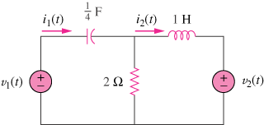

First select the inductor current i_{L} (left to right) and the capacitor voltage v_{C} (+ on the left) to be the state variables.

Letting i₁ = and i₂ = i_{L} and applying KVL we get:
Loop 1:
Loop 2:

